In terraform state file, we cant read the file as it is in binary form. So we make a plan.out file and copy everything in the state file in it by

terraform plan -out=plan.out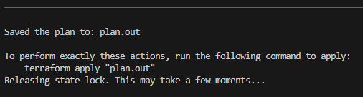

then we can read the file by

cat plan.out

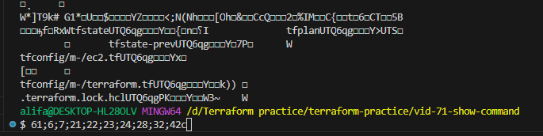

The file is in binary and output is distorted

We can read the file by terraform show plan.out

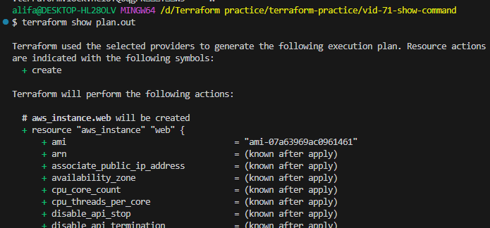

By terraform show command we can read the file.

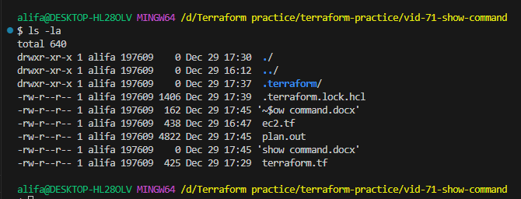

We can see the state and lock files are stored remotely in s3 and dynamodb.

After we hit terraform apply, we can see what has been added by using terraform show command.

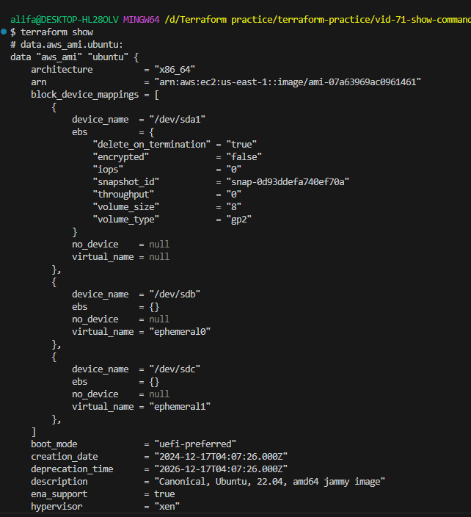

* **The terraform show command is used to provide human-readable output from a state or plan file.**
* **This can be used to inspect a plan to ensure that the planned operations are expected, or to inspect the current state as**
* **Terraform plan output files are binary files. We can read them using terraform show command**
* **By default, in the working directory if we have terraform.tfstate file, when we provide the command terraform show it will read the state file automatically and display output.**